Change Equation: Planning

Adapted from “Gleicher's Formula” by Richard Beckhard and David Gleicher
C = D x V x F
R

Change | Successful change is more assured when the forces above the line outweigh the resistance underneath. The bigger the force on the top the more likelihood of success.
Dissatisfaction | With the way things currently are. How strong is it? How widespread? How well is it published?
Vision | The powerful future vision of what it will be like afterwards.  How clear are we about the new future?  How well is it communicated, discussed and shared?
First steps | Achievable first steps to make it happen. For example, managers need to make sure each employee understands what steps they need to take in order for the change to be successful:  - They need to know what to do to prepare themselves for the change (such as skill development)  - They need to know how they will be contributing to the successful implementation of changes (such as project work, job changes, etc).
Resistance | All the things that are holding the change back. How much intelligence do we have about all the resisting forces?

Kotter’s 8-Stage: Doing
Taken from: (1996) Kotter, J. P. Leading Change. Boston: Harvard Business School, p. 21 with adaptations to make it more relevant to team leaders.
Stage
1/ Establish a Sense of Urgency
2/ Creating the Guiding Coalition
3/ Developing a Vision and Strategy
4/ Communicating the Change Vision
5/ Empowering Broad-Based Action
6/ Generating Short-Term Wins
7/ Consolidating Gains and Producing More Change
8/ Anchoring New Approaches in the Culture

The Path of the Everyday Hero: emotional
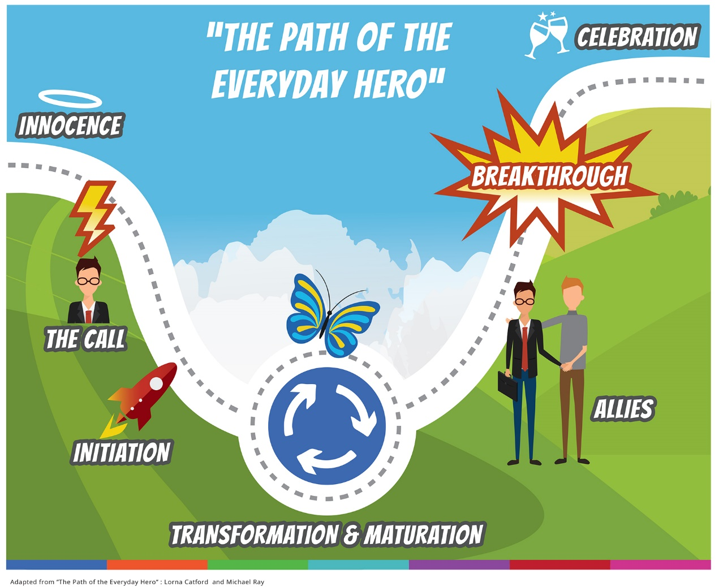
Phase 1 – Innocence  - “Normal” day to day life  - No obvious, major disruptions  - Relatively content  - Reasonably comfortable with the Status Quo  - Relatively naïve state – not anticipating trouble | Phase 4 – Allies  Provide a way forward for successful resolution of the initiation phase  - Friends support, new insights all emerge to help  - Discovery of personal wisdom  - Solutions may appear “simultaneously” with problems – for example “nettles and dock leaves”
Phase 2 – The Call  - Crisis or demand for action  - Represents the “threshold” of period of disruption/challenge  - May experience feelings of loss ability to cope/control  - No apparent option for a quick fix  - Solution may seem impossible  - Go forward or stay stuck?  - Addresses “Secret Yearning” to grow, be all that we can be |  |  | Phase 5 – Breakthrough  - Results from new knowledge, skills and abilities  - Self-discovery, a new way of being  - High motivation and sense of achievement  - Recognition of personal transformation marks return threshold
Phase 3 – Initiation  - The Call is accepted  - Stepping into the unknown  - Facing problems/challenges begins the process of transformation / maturation  - Initially may be lacking confidence |  | Phase 6 – Celebration  - Return to “normal” Life  - New gifts – wiser, deeper, more actualised  - Others benefit from hero’s transformation

