Leading successful change

Will it work?
Change is inevitable – except from a vending machine.  Robert C Gallagher  Author | 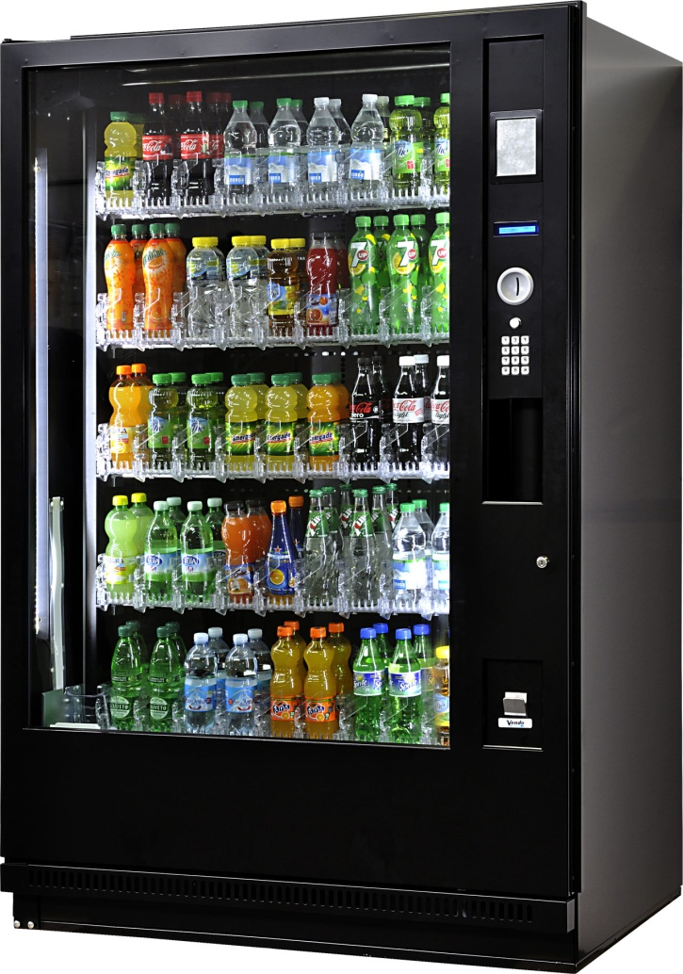

The change equation
Richard Beckhard and David Gleicher created the change equation sometimes called “Gleicher's Formula”. It’s a way of looking at change and its likelihood of being successful. Although called an equation, it’s less about arithmetic and more about helping assess the relative forces affecting the likely success or otherwise of a change idea.

C
R
F
V
D
X
X
The prompt questions that follow help you figure out if what’s planned will work. Or what you need to action to increase the likelihood of it working.

Prompt questions

The Change
What is the change
What’s the compelling reason for it?

Dissatisfaction
How dissatisfied are you and the key influencers with the way things currently are? Score out of ten where ten is highest.
You
Your team
Your manager
Key influencer #1
Key influencer #2
Average score

Vision
How powerful is your vision of what it will be like after the change?
Your powerful vision for what it will be like (30 -50 words)

Your score out of ten

First steps
What are the first few steps to get some momentum going?
Specific action |  | Result | By when
1
2
3

Your score out of ten

Resistance
What are all the things that are holding the change back? Add more rows as necessary. Give each resistor a power rating of high, medium and low.
How much intelligence do you have about all the resisting forces? Think people, politics, personalities, risk, budget holders, trades unions, etc.?

Resistance |  | Power
1
2
3
4

Your score out of ten

Review

Plug into the formula
What | Score | Comment
Dissatisfaction
X Vision
X First steps
÷ Resistance
=

Pause to think
Remembering that your result helps you think and not an arithmetic certainty:
- What’s your sense of your success likelihood?
- What have you noticed in the individual scores, especially within dissatisfaction?
- Where are your scores strong?
- Where do you need to act?
- What could be actions to:
  - Increase people’s dissatisfaction?
  - Refine your vision to make it more compelling?
  - Improve the specifics of your first few steps?
  - Reduce the strength of problematic restraining forces?

What’s next
Are you content that you have enough going for you now to overcome the resistance forces?
If yes: proceed to implement

If no: Action plan what you need to do so that success is more likely

Action plan
Add more rows as necessary
Specific action |  | Who | By when
1
2
3
End

