Agenda builder

Agenda items planning
What | Item or subject
Why | Objective. Why does it need to be a meeting? What’s the intended outcome? Remember the doing word (verb) in the objective. See doing words checklist.
Who | Is involved. Who is responsible
How | Process. What will participants do to meet achieve the objective? Will you need an activity or simple meeting tool to help?  If it is a decision that’s needed – how will you decide, you alone, consensus, majority, etc.  Do you need to lobby people beforehand? If so who and when?
When | How long. What’s the time allocation for it

Doing words selection
A-G | E-R | R-Z
Acknowledge | Enrol | Report
Agree | Generate | Resolve
Analyse | Identify | Review
Assess | Introduce | Secure
Assimilate | Learn | Segment
Build | List | Share
Confirm | Outline | Shortlist
Contribute | Plan | Solve
Create | Present | Study
Decide | Problem-solve | Suggest
Design | Produce | Synthesise
Determine | Recognise | Unblock
Develop | Recommend | Understand
Enable | Record | Update

Example
Good verb |  | clear subject |  | relevant outcome
To agree | the Christmas venue |  | that fits the budget and appeals to the majority

Heroic tip
The chair of this meeting will need to decide what makes a majority – more than half 2/3rds, 75% and so on.

Where on the agenda?
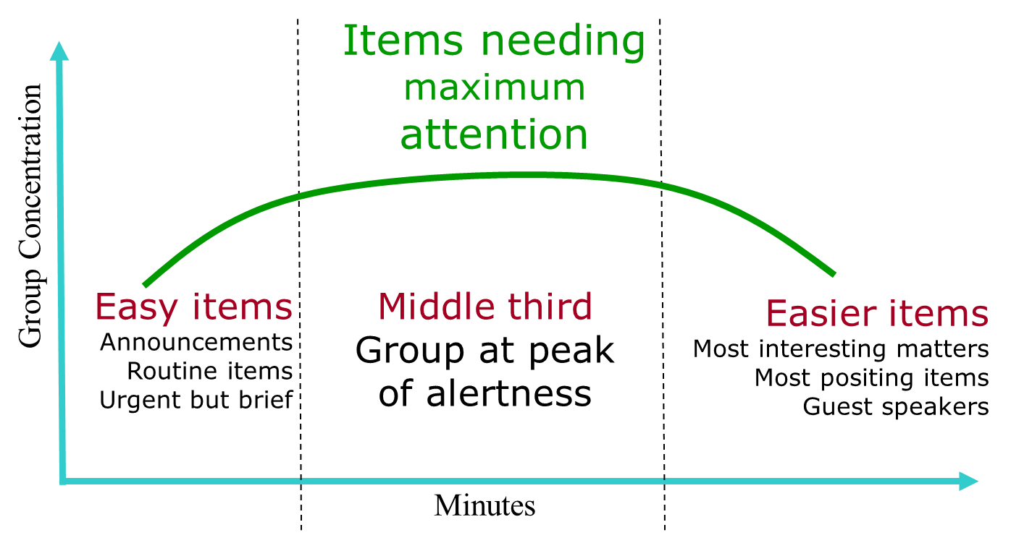
D Sharman, The Perfect Meeting

Process
Is the item quick and will help gather momentum? Initial third
Will the item need deep thinking? Middle third
Is the item positive, a positing one or motivational. Latter third

Vital notes
This is a helper not a straight-jacket
Plan in breaks every 90-minutes. Otherwise, efficiency sags

For each item
What
-subject
Why
-the objective
Who
-responsibilities
How
-process
When
-how long
Where
-on the agenda

What
-subject
Why
-the objective
Who
-responsibilities
How
-process
When
-how long
Where
-on the agenda

What
-subject
Why
-the objective
Who
-responsibilities
How
-process
When
-how long
Where
-on the agenda
What
-subject
Why
-the objective
Who
-responsibilities
How
-process
When
-how long
Where
-on the agenda

End

