Emotional Intelligence (EI)

My name
My manager
V1.0

Contents

Welcome 4
Advance Activities 5
Welcome 9
Emotional Intelligence (EI) 9
Getting behind our thoughts 10
Staying Resourceful 12
Assertiveness 14
Motivation 18
Actions 20
Conscious practice 21

Important notice
This pack is yours for you own development to support your learning. It’s in Microsoft Word format to help you interact with it as easily as possible. As you’d expect the content, design and activities are the IP and copyright of Robertson Training Ltd, trading as Robertson Training.

No part of this can be shared copied or used outside of your own development without the express written consent of Robertson Training Ltd.

You should contact Robertson Training by email at enquiries@robertsontraining.co.uk with any questions about this notice and its implications.

Welcome
In a very real sense we have two minds, one that thinks and one that feels  Dan Goleman  Author, psychologist and science journalist | 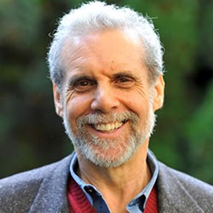
Building Emotional Intelligence is essential in today’s uncertain and complex world.
It is the capacity to understand our emotions and to develop the ability to manage these.
The five key elements of emotional intelligence are:
- Self-awareness
- Self-regulation
- Motivation
- Empathy
- Social skills
Building emotional intelligence helps us in the workplace as it leads to improved collaboration, stronger relationships. These lead to getting results.

The good news is, a large part of it is becoming more aware and appreciating the capabilities you already have along with practice. Even small steps will make a difference and your programme will help you create your own action plan and get the results you want.

Your simple plan to results
1 | 2 | 3
Do the advance activities so that you are prepared | Participate fully in the workshop | Apply your actions at work, capture and reflect on your results

Remember the workshop isn’t so much about delivering knowledge. It’s about activating the advance activities and applying it to the real workplace situations you face.

Advance Activities
It is very important to understand that emotional intelligence is not the opposite of intelligence, it is not the triumph of heart over head – it is the unique intersection of both
David Caruso
Actor and Producer

Your programme is more than just a virtual session, each part is important, each part has activities and actions for you and each part helps you get the results you want.
Before your workshop, you should do the following activities. It’s best to type your responses in the blank boxes with each activity.
Activity # example Est 5 mins
What do you see as three main actions to guarantee my success on this programme?
1 | Plan in time to do the activities, reflect and action plan
2 | Consciously apply my actions
3 | Keep notes of the benefits I get from my actions to motivate me

Emotional Intelligence (EI)
Activity #1 Est 10 mins
Watch the short video clip, in which Dan Goleman introduces Emotional Intelligence (5 mins)
https://www.youtube.com/watch?v=Y7m9eNoB3NU
Afterwards, note your reflections and insights below.
Reflections and insights

Activity#2 Est 10 mins
Our brilliant brain is the most powerful and complex thing we know of in existence. It’s much more vivid in the present than it is thinking in the future.
To help you focus on your success let’s jump ahead and think in the present.
Specifically, it’s now three months since you finished your EI programme.
Complete the table below for yourself. There is an example from a previous participant too.
My measurable success results
It’s now the |  |  | of
Because of my EI actions I am now seeing:
1
2
3
What I am saying to myself is:
1
2
3
What I am hearing others around me say is:
1
2
3
What I’m feeling now is:
1
2
3

Example
My measurable success results
It’s now the |  | 12th | of | Never
Because of my EI actions I am now seeing:
1 | A calmer and more relaxed person when I look in the mirror
2 | Getting through more work because I’m calmer and more focussed
3 | Other people around me responding well to my contributions during meetings
What I am saying to myself is:
1 | I feel much calm and in control
2 | I am motivated to be my best self at work
3 | I communicate assertively
What I am hearing others around me say is:
1 | You’re a different person now. Calmer and much less emotional
2 | How do you manage to keep sane with all that’s going on?
3 | What’s your secret to understanding other people so well?
What I’m feeling now is:
1 | Calm
2 | In-control
3 | More productive

Activity #3 Est 20 mins
Read the following article then make notes in the sections below:
Utilising Emotional Intelligence in the Workplace: https://www.verywellmind.com/utilizing-emotional-intelligence-in-the-workplace-4164713

Emotional Intelligence (EI)
What is it?
Why is important?
What are the workplace benefits?
How do we become more emotionally intelligent?
What are three specific actions you will commit too:
1.
2.
3.

Activity #4 Est 2 mins
Quickly read the following phrases then note the two that you find most motivating at work.

Workplace Motivators
- Taking on new challenges
- Solving problems
- Knowing I made other people happy
- Meeting new people
- Being in charge
- Building connections with coworkers
- Making steady progress toward goals
- Being able to express my opinions freely
- Getting public recognition
- Analyzing all the options
- Working on team projects
- Being in a constantly changing environment
- Helping others succeed
- Getting closure on projects
- Doing a high-quality job
- Being in the limelight
- Taking risks
- Being the expert on a topic
- Producing concrete results
- Having freedom to do things my way

1
2

Activity #5 Est 20 mins
Watch this 10 min video clip on motivation:
RSA Animate: Drive: The surprising truth about what motivates us:
https://www.youtube.com/watch?v=u6XAPnuFjJc&feature=youtu.be
Afterwards, note your reflections below:
Interesting?
Key messages for me?
Connections to my world?
Actions?

Activity #6 Est 15 mins
Watch this 4 min video clip:
Johari’s Window: Self-awareness/Personal Development (4min clip):
https://www.youtube.com/watch?v=XKkK6x5rchg
Afterwards, reflect on the messages a thought-provoker like JoHari’s window has for you. Note your answers to the questions below:
How open are you with people?
How open are they with you?
To what extent do you seek feedback from others’?
Actions?

Advance activities end

Welcome
How you react emotionally is a choice in any situation.
Judith Orloff
Professor and Author

Measurable objectives
By the end of the workshop you will be able to:
- Appreciate Dan Goleman’s definition of EI and his five key elements of EI
- Be able to explain how humans are wired to react in-the-moment, and at least three ways we can manage ourselves more effectively
- Develop deeper self-awareness and understanding of their own core values
- Appreciate the importance of what we say to ourselves and create at least two new internal scripts
- Use practical strategies to respond (not react!) and stay in a resourceful state
- Appreciate the link between motivation and EI, with awareness of the differences between Extrinsic and Intrinsic motivation
- Develop a personal action plan to get results

Workshop agenda
- What is Emotional Intelligence (EI) and why develop it?
- Developing greater self-awareness
- Staying resourceful
- Using assertiveness strategies to respond (not react!)
- Exploring motivation
- Summary
- Next steps and action planning

Emotional Intelligence (EI)
My producer said, ‘You hit a home run’ because you’ve been working for it.
Katy Perry
Entertainer

"Emotional intelligence is the ability to perceive emotions, to access and generate emotions so as to assist thought, to understand emotions and emotional knowledge, and to reflectively regulate emotions so as to promote emotional and intellectual growth."
Mayer & Salovey,1997

According to Dan Goleman, psychologist and popular “Emotional Intelligence guru”, there are five key elements to emotional intelligence which are:
- Self-awareness
- Self-regulation
- Motivation
- Empathy
- Social skills

Process advance activities
Activity #1 15 mins
Group discussion
- My measurable success results are…?
- What were your reflections and Insights from the Dan Goleman video clip
- What is EI?
- Why is it important?
- What are the workplace benefits?
- How do we become more emotionally intelligent?
- What actions will you take?

Notes from discussion

Getting behind our thoughts
I am not afraid of storms, for I am learning to sail my ship.
Louise May Alcott
Novelist and Poet

The Resilience Model
This is a model that represents:
- Who we are
- What we are all about
- What we stand for in the world
It comes from the world of NLP (Communications model) and from Stress Management

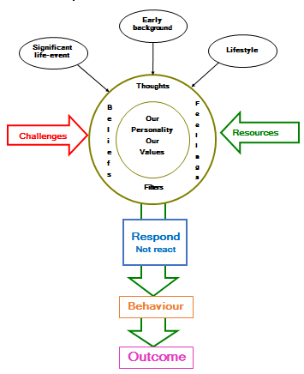
Activity #2 5 mins
My Resilience model notes and reflections

Core Values
Becoming self-aware of who you are means that, you have a deeper understanding of your core identity. It is about knowing what exactly drives you to do things the way you do them. Your values and beliefs are the things that make-up your character which in turn influences your choices, actions and results in life.
Activity #3 30 mins
Download the “HO2 My core values activity pdf” from the “Handouts” section of the dedicated web page.
Complete the activity, to identify and align with your own core values

Staying Resourceful
You must manage yourself before you can lead someone else.
Zig Ziglar
Sales guru
To effortlessly think on your feet, you need to stay resourceful. In that way you can be at your best. You stay thinking. If you stay thinking you can always respond to what’s going on.
What we say to ourselves is the most powerful influence on our behaviour. It’s vital therefore that we have powerful and constructive self-talk with ourselves.
Our actions are firstly to make sure we can stay positive about ourselves. Secondly to catch ourselves falling into negative self-talk about ourselves, our skills and our abilities. Second guessing the other person’s reactions is unhelpful to us too. When we are being unhelpful to ourselves, we can change that self-talk into something more helpful.
Here is an example to illustrate:
What I say to myself | What I will say to myself
Barry Scott’s aggressive. He doesn’t like me. He will pick holes in any points I make and my mind will go blank. | I have researched my case and will stay calm so that I can respond to any counter points he might make.  If I believe he is being aggressive I will stay assertive.

Activity #4 15 mins
Now do it for two of your own examples
Unhelpful self-talk | Constructive self-talk
What I currently say to myself | What I will say to myself

Resourceful state of mind
Self-talk goes a long way to staying resourceful. Because we stay resourceful, we have all of our brain processing power available to use. We stay thinking. As Dr Susan Jeffers says in her book; Feel the fear and do it anyway “I’ll handle it.”
Activity #5 10 mins
Group discussion
- When we get emotionally hooked:
- What’s happening to us?
- How is it showing in our behaviour?
- What’s the impact on the outcome?
- What specific things get us hooked?
- How can we help ourselves:
- Before, during and after interactions
- What’s our emerging actions?

Notes from discussion

Red rags
One thing that can knock us from staying resourceful is getting hooked into our Red rags. These are statements or approaches that people use with us that get us angry, emotionally hooked and risk placing us in a reaction state. This instinctive reaction mode stops us thinking. We get emotionally hooked resulting in us losing our ability to think.
It’s important in our challenging situations to know what our hot buttons are, what are our Red rags. Then we can help to manage ourselves.
Case study: Derek and the NHS
Derek broke his nose (long story). The NHS called him and offered him one day and time for a consult. Derek explained that he had people flying in to Edinburgh from six different countries and so couldn’t make that time. He offered to see the consultant early that morning or after 5pm that night.
The nurse said, “What you have to understand is that we are only open from 10 am till 4pm. Most people prioritised their health over work.
For Derek being told what he “has to understand” is a Red Rag for him. He got cranky, stopped thinking and the conversation ended badly for everyone.
Activity #6 10 mins
What are Red Rags for you and what can you do to deal with them?
Red rags for me are | Ways of dealing with them for me are

Permission
You can help yourself to respond calmly by giving yourself permission.
- Permission to do certain things.
- Permission to not do certain things.
- Permission to let go of certain things.
Whatever these ‘things’ are, they have helped us be who we are today. It’s ok to acknowledge them while letting them go.
Natalie
Natalie came to realise that her mind went blank when she was in discussions with very senior people. Eventually she realised that as a kid she was continuously reminded to respect her elders and that grown-ups always know best.
It took a while for Natalie to give herself permission to discuss, share and even challenge people in authority. She did it and can now think on her feet every single time
Activity #7 15 mins
Make your own notes here about what you need to give yourself permission to do.
Permission
1 | From this moment I give myself permission to . . .
2 | From this moment I give myself permission not to . . .
3 | From this moment, I give myself permission to let go of . . .

How might you make sure you keep your commitment to yourself
1
2
3

Assertiveness
“The only healthy communication style is assertive communication.”  Jim Rohn  Entrepreneur | 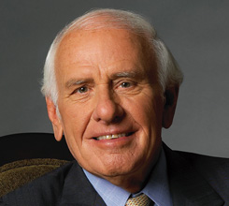

In almost everything that you do, behaving assertively is a foundation skill. It is vital therefore that as managers we know what it is and how to do it.
This is our preferred definition of what you do when you behave assertively.

Behaving assertively is . . .
Standing up for your own rights in such a way that you do not violate another person’s rights
Expressing your needs, wants, opinions, feelings and beliefs in direct, honest and appropriate ways
Ken and Kate Back
Assertiveness at Work Third Edition

As a way of taking this definition and giving you something that you can use immediately we would invite you to WIN. We mean speak with people about What the situation is, Impact and Next steps. Here is an example:

The WIN 3-step process
What | Describe specifically what the situation/behaviour/action is
Impact | Describe the impact that this had. It can also be very powerful to add a feeling word in, that represents how it made you feel
Next steps | Make a suggestion or request as to what they can do differently/better and invite their response

What | I noticed that you began work after break at 11:18am. That’s eight minutes later than we agreed.
Impact | It’s meant that others have had to cover for you.
Next steps | I’d like you to manage your time so that you are back, and working, on time from now on. Will you do that for me?

You will see that this assertive statement is:
- Within the definition
- Uses facts (and not opinions and judgements)
- Is clear about future expectations
Activity #8 15 mins
Help this person re-phrase their communications by scripting a more assertive response to the situation.
Reframe the following:
1 | “Forgotten our watch have we?” (This person has come in after the 8:30am start time again and it’s irritating you).
2 | “You’re careless. This report is full of mistakes!” After submitting a 3-page report with 10 errors.
3 | “You overhear a colleague telling a customer, ‘Well it’s your fault that your cheque was late getting to you not mine.’ You respond with “You have to realise that you can’t speak to people like that.”
4 | “I’d like you to do less moaning at team meetings because it’s dragging the team down.”

How confident are you that you understand basic assertiveness? (Circle one rating).
0 . . . . 1 . . . . 2 . . . . 3 . . . . 4 . . . . 5 . . . . 6 . . . . 7 . . . . 8 . . . . 9 . . . . 10
Not at all confident |  | Extremely confident

Additional assertiveness tools
Ken and Kate Back offer additional tools to help you behave assertively in different situations.
Type | What | Examples
Basic | A straightforward statement that stands up for your rights by making clear your needs, wants, beliefs, opinions or feelings. | “I see the system is working well.”  “I didn’t understand what you’ve just said.”  “In this team we support one another.”
Empathetic | A behaviour that contains an element of empathy as well as a statement of your needs and wants. | “I appreciate that you don’t want to use the script Jenny. It’s very important to the team that you learn it because we have the research that proves it will work. I’d like you to make a start today.”
Discrepancy | A statement which points out the difference between what has previously been agreed, and what is actually happening or about to happen. | “Dave, when we spoke last week I remember you saying that you would volunteer to help your colleagues when you finished your work. I’m still keen for you to do that.”
Negative Feelings | A statement which draws the attention of another person to the undesirable effect that their behaviour is having on you. It can contain the following elements:  - When . . .  - The effects are . . .  - I feel . . .  - I’d like . . . | “When you don’t want to cover shifts, it involves needless extra time for me and uneven shifts to others. It annoys me because it is absolutely a part of being a team member here. I’d like to see an improvement from you starting from now.”
Consequence | A statement that informs another person of the consequences for them of not changing their behaviour. It also gives them an opportunity to change that behaviour. | “I’m not prepared, Emma, to have you attend team meetings and discussions and not contribute. I expect a change beginning at our next meeting otherwise I may be left with having to take more formal steps with you. Obviously, I’d prefer not to go down that road.”
Responsive | A behaviour that aims to find out where the other person stands, their needs, wants, opinions and feelings. | “What problems does that create for you?”  “What would you prefer to do?”  “John, I’d like to hear your views on this one.”

Activity #9 5 mins
Answer the following questions on Assertiveness tools:
What do you think about these tools?
Which one(s) can you imagine using?
Actions?

Motivation
“Today you are you, that is truer than true. There is no one alive who is youer than you.”
Dr Seuss
Author

Intrinsic motivation is another important emotional intelligence skill. People who are emotionally intelligent are motivated by things beyond external rewards like fame, money, recognition, and acclaim. Instead, they have a passion to fulfil their own inner needs and goals.
At work, employee’s needs haven’t changed in decades. As far back as ‘Management by Objectives’ research in 1970, team members wanted their managers to:
Clarify my job and the results I’m expected to achieve.
Give me the resources and opportunity to perform.
Let me know how I’m getting on.
Give me guidance and training when I need it.
Reward me according to my contribution.

Old and new
Motivation has evolved. In olden days (before 1995!) organisations applied motivators to everyone or every grade. Now we understand that it’s an individual thing. There may be benefits like pension to everyone. But even here organisation now offer choice. And within teams, we have already seen that one person may be highly motivated to get their picture in the company magazine while another would be mortified.
Knowing what we know, it’s logical therefore to know your people. And you can’t know your people unless you have a relationship with them.
Invented by Psychologists Joseph Luft and Harry Ingham, the Johari Window help us to understand self-awareness and the human interaction that results from our personal self-awareness. ... The premise behind the window is that there are certain things which we know, and things we do not know about ourselves.

JoHari Window
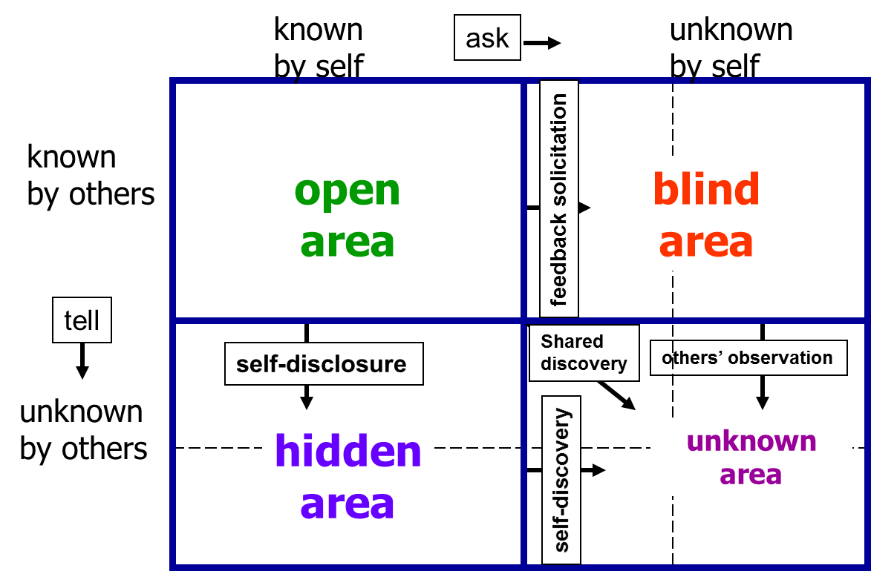
Activity #10 5 mins
Reflections from JoHari window discussion

Activity #11 5 mins
Reflections from “What motivates you?” word cloud

Activity #12 5 mins
Reflections from Dan Pink Motivation clip

Actions
If your actions don’t live up to your words, you have nothing to say
Dr DaShanne Stokes
Sociologist

My specific actions

Action plan tips
- Keep it reasonable: One action at a time successfully, is better than ten actions that fall flat.
- Use the Results progress checklist that follows to tick off things you’ve done.
- Assess your success against your planned outcomes in your Results helper.
- Reward yourself for successes along the way.
- Remember to involve and get feedback from your team.
- Share your actions and commitments with your manager to help give you the push to do them.

Action plan
 | Specifically, I’m going to . . . | By when
1
2
3
4
5
6
7 | Add more rows as necessary

The support I need is . . .
The biggest challenge to my success is . . .
I will overcome it by . . .
I know that I will have been successful when . . .
I will reward myself with . . .
If I don’t apply my actions . . .

Support on your dedicated webpage
Remember you have more things to help you here:
- Downloads
- Links
- Videos
It’s always good to check it as we updated it regularly.

Conscious practice
Life can only be understood backwards; but it must be lived forwards.
Søren Kierkegaard
Philosopher and Theologian

Reflections
Date
What did you do and why
What are you pleased about and why did you learn for next time
What was the result/What’s next

Reflections
Date
What did you do and why
What are you pleased about and why did you learn for next time
What was the result/What’s next

Reflections
Date
What did you do and why
What are you pleased about and why did you learn for next time
What was the result/What’s next

End

